COM 2002: Human-Centred System Design

Group Assignment

Group 6:

Jake Sturgeon

Ruairi Sinkler

Zer Jun Eng

Jia Hua Ng

In this assignment, we are tasked to design a prototype of an information system to manage client registration, appointments and fee calculation for the private dental practice, Sheffield Dental Care. The assignment is done in the Model-View-Controller architecture.

The view portion of the assignment is done by Jia Hua Ng and Zer Jun Eng. The user interface is done in Java Swing, using mainly the WindowBuilder plugin in Eclipse. The user interface starts with a login frame, allowing the user to select the partner or secretary interface. The two interfaces are individual JFrame classes themselves, with JDialogs that are tied to each of them. The JDialogs are generally used for query and data output.

The model part is done by Ruairi Sinkler and Jake Sturgeon. The models are done by referring to the UML diagrams we drew, with each class representing a data. The database is first made on our SQL account, creating tables for each class to store values.

The controller part is done in join effort of all four members. Ruairi Sinkler and Jake Sturgeon did the queries function for the database, allowing the program to get, update or delete the selected data from the database itself. For the UI part, Jia Hua Ng and Zer Jun Eng did the functions and implementation for displaying data on UI and the EventListeners. The functions for turning the inserted values into SQL comprehensible code is also done by them, using the queries functions previously mentioned to parse them back into the database.

For the report, we undergraduates needed to design three UML diagrams, the use case diagram, information model and the normalised data model. We designed the diagrams together, with each of us producing a diagram of our own, and then compare with one another to produce a final diagram.

UML Use Case Diagram

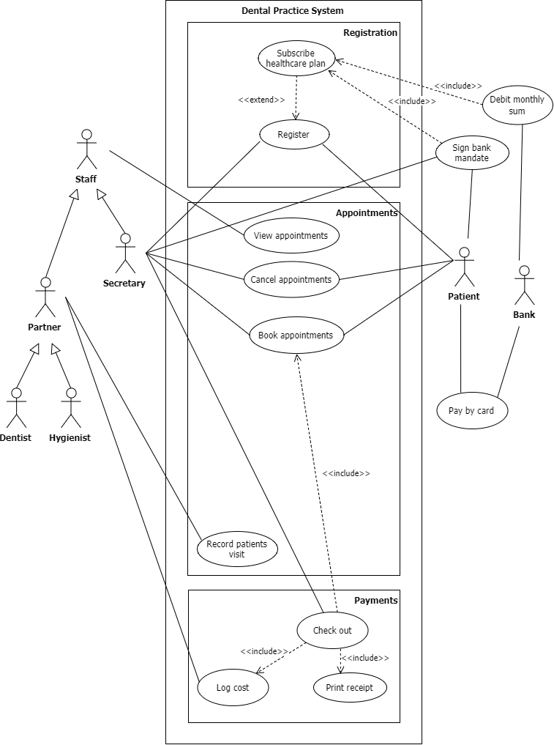

UML Information Model

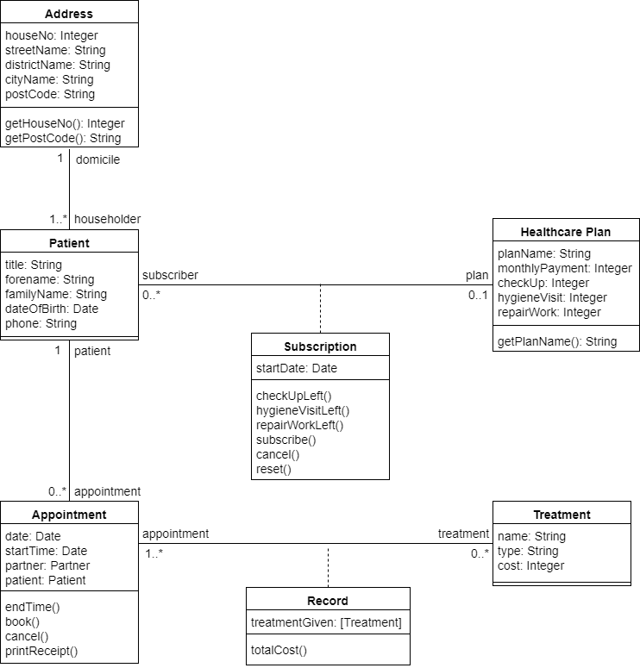

UML Normalised Information Model

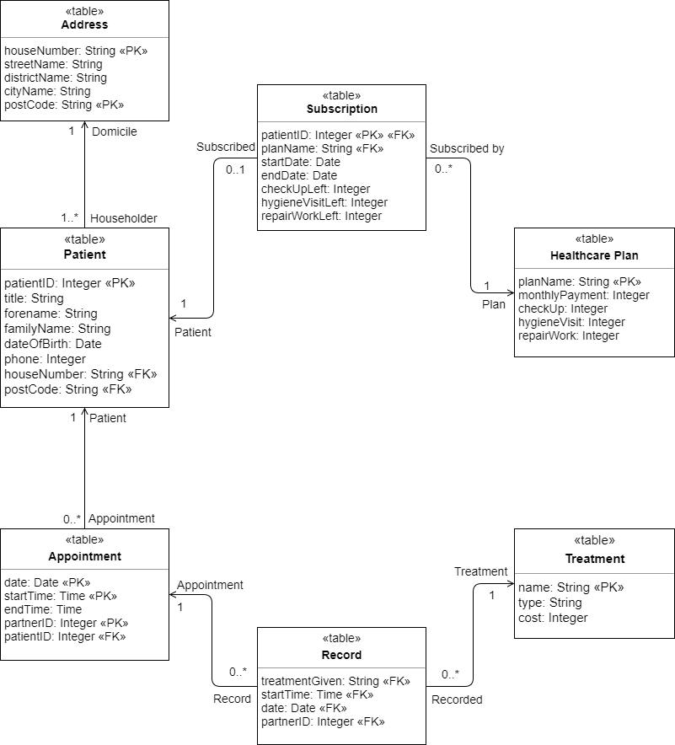

Effort Declaration

I, Jia Hua Ng is generally in charge of the User Interface, and also take part in a lot of the coding for the printing of data and parsing of data from the User Interface. I worked hand in hand with Zer Jun Eng, designing the early concept of the UI while he tidies and makes the UI more organised. I was also in charge of appointment part of the data parsing, doing all the codes of printing, editing, viewing and refreshing the tables for both the partners and secretary. I have also done all codes for booking appointments, checking if patient or partner has valid time for the time selected.

I, Zer Jun Eng is in charge of User Interface, as well as the coding for Patient Table Management, Partner Appointment Editing, and Receipt.